RESOLUTION NO.__________

RE: CERTIFICATE OF APPROPRIATENESS UNDER THE
PROVISIONS OF THE ACT OF THE PENNSYLVANIA
LEGISLATURE 1961, JUNE 13, P.L. 282 (53
SECTION 8004) AND BETHLEHEM ORDINANCE NO.
3952 AS AMENDED.

WHEREAS, it is proposed to replace 15 windows on the second floor Main St. façade of Main St. Commons at 559 Main St.

NOW, THEREFORE, BE IT RESOLVED by the Council of the City of Bethlehem that a Certificate of Appropriateness is hereby granted for the proposal.

Sponsored by: (s)

(s)

ADOPTED BY COUNCIL THIS DAY OF

(s)
President of Council

ATTEST:

(s)
City Clerk

HISTORICAL & ARCHITECTURAL REVIEW BOARD

The applicant proposes to replace 15 windows on the second floor Main St. façade of Main Street Commons at 559 Main St.
APPLICATION #2:

Rubel Street LP
559 Main St.
Bethlehem, PA 18018

OWNER:

__________________________________________________________________

The Board upon motion by Phil Roeder and seconded by Nancy Shelly adopted the proposal that City Council issue a Certificate of Appropriateness for the following:

- Replace 15 windows with Pella wood windows in sizes and color to match existing.

2. The existing frames, sills and trim will be repaired as required.

3. The motion was unanimously approved.

__________________________________________________________________________

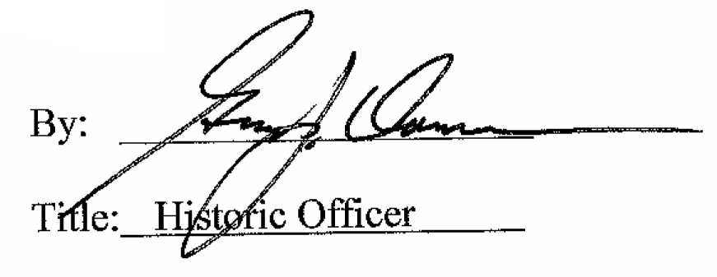

Date of Meeting: January 6, 2016

